ARYAMAN MISHRA

19BCE1027

1. <!DOCTYPE html>

<html>

<head>

<title>Average Calculaor</title>

</head>

<body>

Enter the name: <input type="text" id="name" required><br>

Enter the Maths marks: <input type="text" id="maths" required><br>

Enter the English marks: <input type="text" id="eng" required><br>

Enter the Hindi marks: <input type="text" id="hindi" required><br>

Enter the Physics marks: <input type="text" id="phy" required><br>

Enter the Chemistry marks: <input type="text" id="chem" required><br>

<button onclick="Student()">Student Average</button>

<button onclick="classavg()">Class Average</button>

<br>

<ol id="class">

</ol>

<div>The Class Average is <span id="ans">NULL</span></div>

</body>

<script>

var nameArray = Array();

var avgArray = Array();

var e = ""

function Student()

{

var name = document.getElementById("name").value;

if (name!= ""){

nameArray.push(name);

var maths = parseInt(document.getElementById("maths").value);

var eng = parseInt(document.getElementById("eng").value);

var hindi = parseInt(document.getElementById("hindi").value);

var phy = parseInt(document.getElementById("phy").value);

var chem = parseInt(document.getElementById("chem").value);

var sum = maths + eng + hindi + phy + chem;

sum = sum/5;

avgArray.push(sum);

alert(sum);

}

document.getElementById("name").value="";

document.getElementById("maths").value="";

document.getElementById("eng").value="";

document.getElementById("hindi").value="";

document.getElementById("phy").value="";

document.getElementById("chem").value="";

e += "<li>Name: " + name +" , Average: " + sum + "</li>";

document.getElementById("class").innerHTML=e;

}

function classavg() {

var sum = 0;

for (var i=0;i<avgArray.length;i++) {

sum+=avgArray[i];

}

sum = sum/avgArray.length;

document.getElementById("ans").innerHTML=sum;

}

</script>

</html>

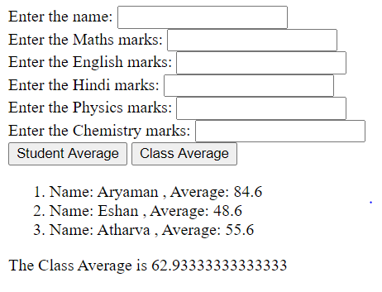

2) <!DOCTYPE html>

<html>

<head>

<title>EPF</title>

</head>

<body>

<script type="text/javascript">

function calc(){

var sal=parseInt(document.getElementById("sal").value);

var a=parseInt(document.getElementById("age").value);

var o1=document.getElementById("o1");

var o2=document.getElementById("o2");

var pf=0,pe=0,per=0;

if(sal<=20000){

pf=0.1;

pe=0.4;

per=0.6;

}

else if(sal>20000 && sal<=60000){

pf=0.08;

pe=0.6;

per=0.4;

}

else if(sal>60000){

pf=0.05;

pe=0.6;

per=0.4;

}

if(a>=60)

pf+=0.2;

var pfval=pf*sal;

var emp=pe*pfval;

var empr=per*pfval;

o1.innerHTML=emp;

o2.innerHTML=empr;

}

</script><label style="margin-left: 500px;">Salary: </label><input type="text" id="sal" value="" style="margin-top: 200px;margin-left: 70px;"><br>

<label style="margin-left: 500px;">Age: </label><input type="text" id="age" value="" style="margin-top: 40px;margin-left: 85px;"><br><br>

<label style="margin-left: 500px;">Contribution of employee: Rs </label><label id="o1"></label><br><br>

<label style="margin-left: 500px;">Contribution of employer: Rs </label><label id="o2"></label><br><br>

<button onclick="calc()"/>Submit</button>

<style type="text/css">

body{

background-color: #fdd;

}

input[type="text"]{

width: 200px;

height: 30px;

}

button{

cursor: pointer;

background: #44c4e7;

width: 15%;

padding: 10px 15px;

border: 0;

color: #fff;

font-family: "Calibri";

font-size: 20px;

font-weight: 400;

padding: 10px 10px;

margin-left: 550px;

}

button:hover {

background: #369cb8;

}

</style>

</body>

</html>

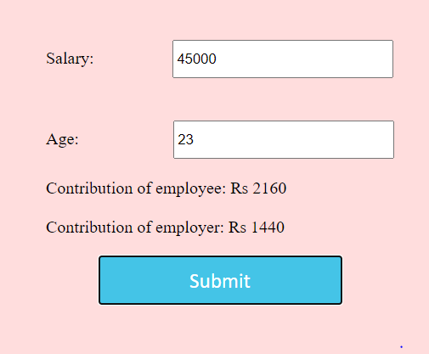

3) <!DOCTYPE HTML>

<html>

<head>

<title>

How to change the background color after

clicking the button in jQuery ?

</title>

<script src =

"https://ajax.googleapis.com/ajax/libs/jquery/3.4.0/jquery.min.js">

</script>

</head>

<body style = "text-align:center;">

<h1 style = "color:black;" >

Aryaman Mishra

</h1>

<p id = "GFG_UP" style =

"font-size: 16px; font-weight: bold;">

</p>

<input type="button" value="red" class="buttonred"/>

<input type="button" value="green" class="buttongreen"/>

<input type="button" value="blue" class="buttonblue"/>

<p id = "GFG_DOWN" style =

"color:green; font-size: 20px; font-weight: bold;">

</p>

<script>

$('#GFG_UP').text("Click on button to change the background color");

$('input.buttonred').on('click', function() {

$('body').css('background', 'red');

$('#GFG_DOWN').text("Background Color Changed!");

});

$('input.buttongreen').on('click', function() {

$('body').css('background', 'green');

$('#GFG_DOWN').text("Background Color Changed!");

});

$('input.buttonblue').on('click', function() {

$('body').css('background', 'blue');

$('#GFG_DOWN').text("Background Color Changed!");

});

</script>

</body>

</html> 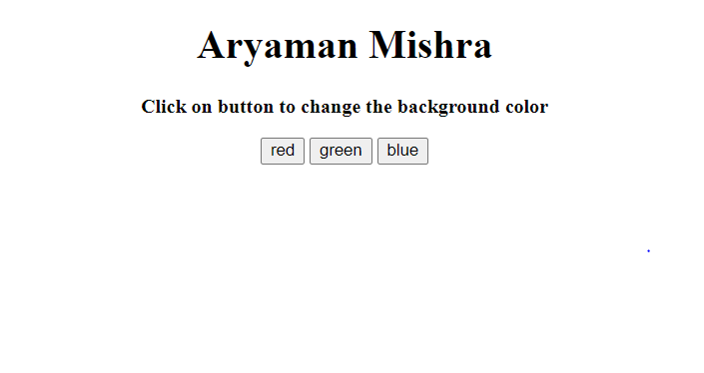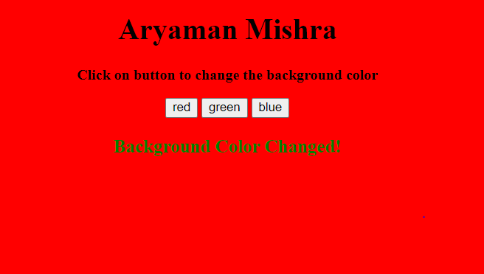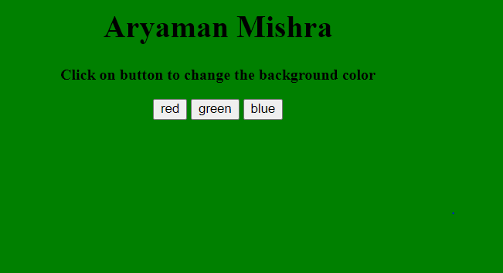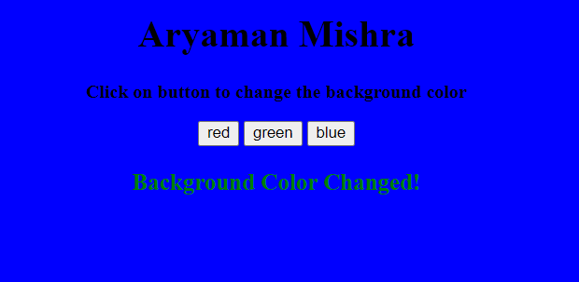

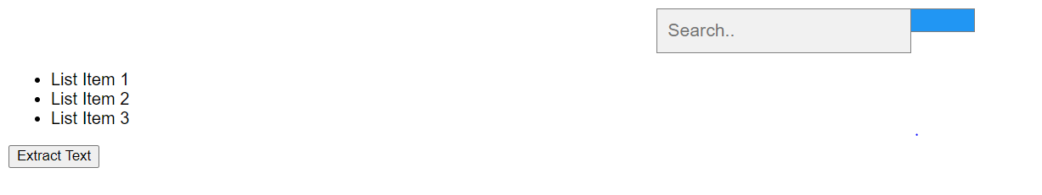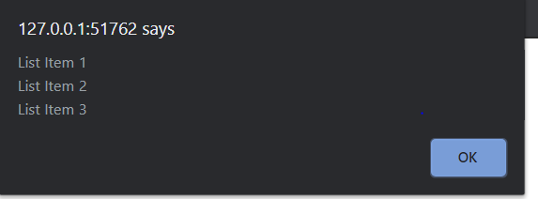

<!DOCTYPE html>

<html lang="en">

<head>

<!-- title for page -->

<title>HTML list</title>

<meta charset="UTF-8">

<meta name="viewport" content="width=device-width, initial-scale=1">

<style>

body {

font-family: Arial;

}

* {

box-sizing: border-box;

}

form.example input[type=text] {

padding: 10px;

font-size: 17px;

border: 1px solid grey;

float: left;

width: 80%;

background: #f1f1f1;

}

form.example button {

float: left;

width: 20%;

padding: 10px;

background: #2196F3;

color: white;

font-size: 17px;

border: 1px solid grey;

border-left: none;

cursor: pointer;

}

form.example button:hover {

background: #0b7dda;

}

form.example::after {

content: "";

clear: both;

display: table;

}

</style>

</head>

<body>

<form class="example" action="/action_page.php" style="margin:auto;max-width:300px">

<input type="text" placeholder="Search.." name="search2">

<button type="submit"><i class="fa fa-search"></i></button>

</form>

<ul>

<li>List Item 1</li>

<li>List Item 2</li>

<li>List Item 3</li>

</ul>

<!-- button -->

<input type="button" value="Extract Text" onclick="extractText()"/>

<!-- script is used for javascript -->

<script>

function extractText()

{

//take the list items and display text

alert(document.getElementsByTagName("ul")[0].innerText);

}

</script>

</body>

</html>